**Documentation:**

* 2003-2004 (3 Phenols measured, replacement not present)

* 2005-2006 (replacement not present)

* 2007-2008 (replacement not present)

* 2009-2010 (replacement not present)

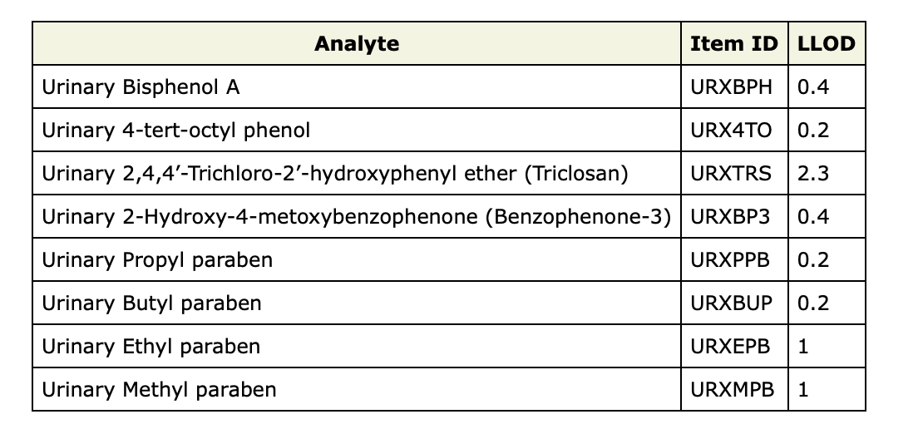

* 2011-2012 (replacement present)

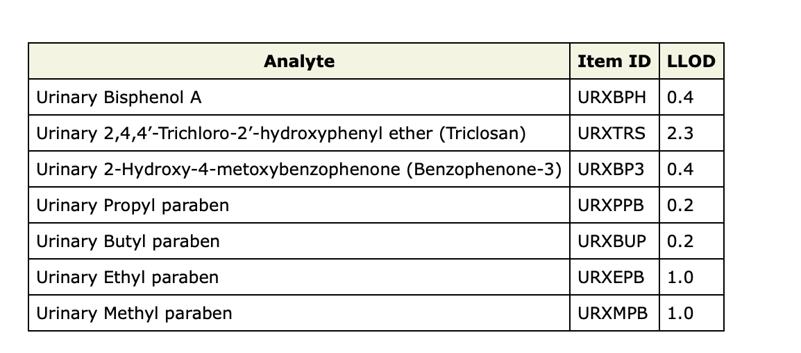

* 2013-2014 (replacement present)

* 2015-2016 (replacement present)

